FPGA Neural Network  
Digital Systems Design - Dr. Reddy, Fall 2009

**Alex Karantza**

**Sam Skalicky**

Artificial Neural Networks are an intriguing application of digital electronics. Using digital systems to approximate natural analog behavior opens up new possibilities for solving problems generally considered ill-conditioned or too complex for ordinary algorithms. In this project, a VHDL implementation of a small artificial neural network on a Spartan 3E-100 FPGA is shown, and its implications for problem solving and performance discussed.

## About Neural Networks

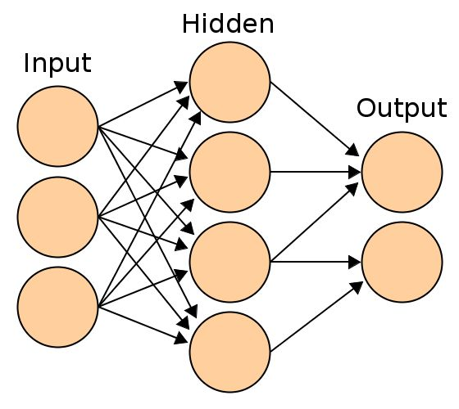 The history of computer science is filled with attempts to mimic biological systems using technology. Artificial intelligence was - and to many still is - the Holy Grail of computing theory. The mathematical models of many kinds of biological systems, including intelligence, were discovered and improved throughout the past hundred years. Genetic algorithms model the process of genetic mutation and evolution to optimize some kind of function. Neural networks are another kind of optimization function, modeled after the functional understanding of the cells (neurons) that make up the animal nervous system.

The actual nervous system is a very complex electro-chemical system, operating by accumulating ions and transmitting them through cell membranes and manipulating the density of neurotransmitters. Artificial neural networks simplify this system.

An artificial neural network of the kind presented here (feed-forward with back-propagation) is a graph consisting of three layers of nodes, called "neurons," each of which may be fully connected to the next layer. Each of these neurons acts as a multiply-and-accumulate operator, generating a weighted sum of the outputs of the nodes in previous layers. Each connection between these nodes represents a weight. Once this weighted sum is calculated, the neuron's output is determined by a nonlinear function - large positive sum values produce outputs close to one, large negative sum values result in outputs close to zero. This kind of function is known as a "sigmoid". Once these values have propagated through all three layers, the output of the final layer of neurons is the final output of the whole network.

This fundamental operation, however, does not explain the allure of using neural networks for problem solving. The key is that, like a human brain, this network can learn. By adjusting the connection weights properly, the output neurons can describe *any* function of the inputs, including functions specified only incompletely, or by example. The algorithm for adjusting these weights can be thought of as running the network backwards - propagating the final error back through the weighted connections. By considering the error as a function of the weights, one can use calculus to minimize this and train the network.

## Mathematics of THE ALGORITHM

As said previously, a neural network is a composition of nonlinear functions. By adjusting the weights in this composition, and performing sufficiently many compositions, any smooth n-dimensional function can be approximated. This can be described mathematically as follows.

Suppose a neuron *m* is in the hidden or output layer. It is connected to *n* neurons in the previous layer. When the network is run forward - with external inputs determining the "output" of the input layer - the neuron will perform the following weighted sum:

After the weighted sum of the previous layer is found, it is passed through a sigmoid function. This takes large values of the sum and clamps them to one, and takes large negative values and clamps them to zero, while remaining continuous and differentiable over the reals.

This output is then fed forward to the next layer, and so on, until the output layer.

The learning of the network is essentially a gradient descent operation using a kind of Newton's Algorithm to find the minimum of the error with respect to the weights. With the following derivation, we can find how to both propagate the error through the network and how to adjust the weights properly.

The change of the sum with respect to the inputs is simply the output of the previous run.

And the derivative of the sigmoid function is a simple function of itself, which we've already computed.

When we now look at , we see that it is simply the weighted sum of the errors from the following layer. This is known as the *Delta Rule* in most literature.

When we combine these functions together into a practical algorithm, we find that one must perform a weighted sum of errors leading from the output neurons (where their error is the difference between their result and their target) up through to the input layers. Then, by modifying the weights a fraction () of we can slowly minimize the overall error.

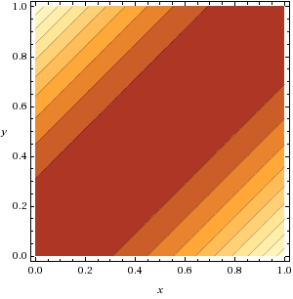 Here is a plot of the output of a network trained to process XOR. The boolean conditions of (0,0), (0,1), (1,0), and (1,1) can be seen to have an output of 0, 1, 1, and 0 respectively. What is more interesting is that the network - through attempting to minimize error at those four points - has created a full two-dimensional gradient that gives meaning to the XOR of arbitrary real numbers. For instance, (0.5) ⊕ (0.5) gives 0, since they're "the same", while (0.8) ⊕ (0.1) gives approximately (0.7), saying that they're "70% different." This simple example outlines the usefulness of training neural networks by example, and allowing them to learn their own topology and extrapolate to unseen inputs.

## Implementation

This project implemented a neural network capable of learning any two-input function, such as AND, OR, XOR, etc, using two input neurons, three hidden neurons, and one output neuron, with nine weighted connections total. This is the smallest network that is practically useful, but it could be expanded to any number of inputs and outputs, operating on any number of degrees of freedom, simply by increasing the number of nodes; no additional components would need to be designed.

The core of the project is four VHDL entities. They each realize some part of the equations given above, and are arranged in a structural form so the connections between them match up to the common theoretical depictions of feed-forward neural networks.

### Neuron

The most critical component is, of course, the neuron. The neuron has signal inputs (, a signal output (), error inputs (, and an error output (. When the signal inputs change, the neuron computes the new sum of those inputs. The summed value is then passed into the Sigmoid component (discussed later) which determines the final signal output. A similar thing happens when the error inputs change; their sum is calculated, and then multiplied by the sigmoid derivative ( to become the error output.

### Connection

The Connection components serve as the weights connecting the layers of neurons. They receive the signal and error values from the two neurons they connect, weight those values, and pass them along. Additionally, the Connections may be put into learning mode. When the error value changes, it is not only propagated along but the Connection modifies its internal weight by the equation derived in the previous section (

### Sigmoid

The neuron needs a nonlinear activation function to apply to its output. To this end it instantiates the Sigmoid entity. This entity, more than all the others, has undergone the most revisions and is most responsible for the network's performance. The sigmoid, , is a difficult expression to compute accurately in digital logic. For the gradient-descent approach to learning to be effective, the function used must not only approximate the sigmoid in value, but also in the first derivative. For reasons discussed later, the final implementation of this entity consists of a piecewise linear approximation. This lack of precision, especially far from the origin, has been the culprit of the numerical issues faced in testing.

### Network

The network entity is what puts together the Neurons and the Connections to decide the topology of the neural net. Numerous internal signals are used to establish the connections between instantiated components. In a less academic implementation, this entity would likely use for-generate statements to build a network of the required size and dimensionality as part of a larger system. The I/O to this entity exposes two values for input, one value for output, a value for entering in the error in the output, and a value for determining if the network is in learning mode.

### Interface & Testbench

Other entities such as test benches and generators were created for debugging and simulation purposes. Additionally, an entity was made to interface the Network component with the netlists providing access to the FPGA board's physical I/O. **<How we use the demo board's IO>**

Internally all the calculations are done using custom fixed point arithmetic. **<Explain why we did this, and why not floats, and how we could have improved with floats>**

## Testing

**<Simulation in ModelSim>**

**<Physical testing>**

## Results

**<Modelsim vs C implementation>**

**<Testing on the xilinx demo board>**

**<Device utilization>**

|  |  |  |  |
| --- | --- | --- | --- |
| Total resources used: 19% | **Device Utilization Summary** | | |
| Logic Utilization | Used | Available | Utilization |
| Number of Slice Latches | 22 | 1,920 | 1% |
| Occupied Slices | 197 | 960 | 20% |
| 4 input LUTs | 360 | 1,920 | 18% |
|  | Logic | 328 | 17% |
|  | Route-thru | 32 | 3% |
| Number of bonded IOBs | 10 | 108 | 9% |
| MULT18X18SIOs | 4 | 4 | 100% |
| Table : Device Utilization table for Spartan 3E-100 | | | |

**<Performance on the fpga>**

|  |  |  |
| --- | --- | --- |
| **Node** | **Levels** | **Time** |
| Data In | 29 | 13ns |
| Data Out | 2 | 5ns |
| Table : Data Speed | | |

## Future Work

**<Talk about what would be needed of a board to implement the Taylor series, better IO system to solve problems like robotic motion or pattern recognition>**

## Conclusion

This project has demonstrated the feasibility of applying a theoretical understanding of neural networks to the design of a parallel asynchronous digital system, and the speed benefits of such efforts. While the ability of the prototype configured for this demonstration is rather shallow, the principles are applicable to systems of any size, and the nature of the equations lead themselves well to even more parallel systems. The prototype was limited by the computational resources available on the FPGA chosen - the lack of sufficient hardware multipliers or a floating point unit. All these problems could be easily overcome if a practical neural network was desired for quickly solving ill-conditioned problems, for learning based on fragmented examples, or for helping to gain an insight into the function of biological neural networks.